Session 2024-25
Experiential learning-MEL0341/Manufacturing Technology-II and MEL0442/Machining Process

Project-Based Learning (PBL) Report on Fabrication of Power Hacksaw

Abstract: This Project-Based Learning (PBL) report focuses on the design, fabrication, and performance evaluation of a power hacksaw. The power hacksaw is a mechanical device used for cutting metals and wood efficiently. This project emphasizes hands-on learning, problem-solving, and collaboration among team members to achieve a practical engineering solution. The students of B.Tech Mechanical V Sem involve in this PBL.
List of students-
- Sujal Kushwah – BETN1ME22001
- Jugal Rawat – BETN1ME22005
- Dhruv Verma – BETN1ME22007

Under the guidance of Mr. Arun Singh Kushwah, Assistant Professor -ME/SOET

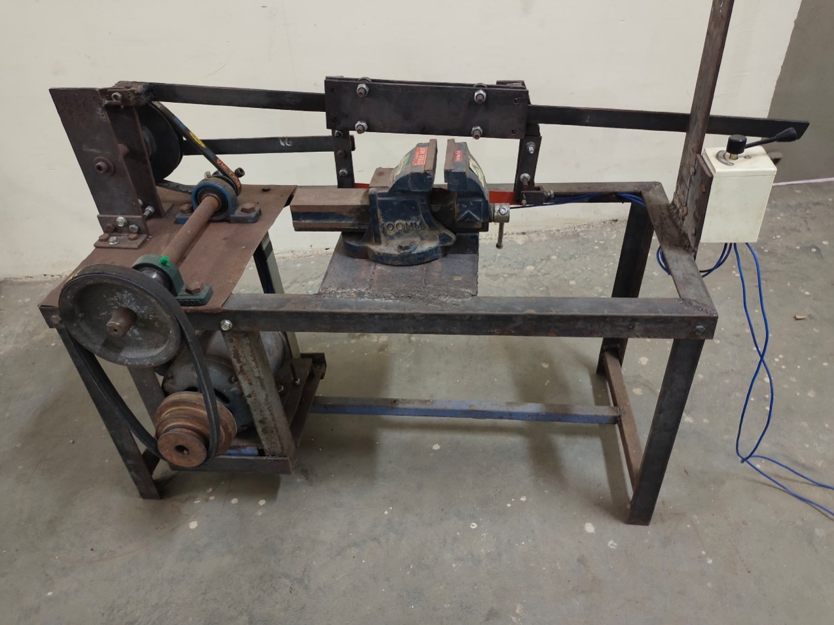

1.Introduction: The power hacksaw is a mechanized tool designed to overcome the limitations of manual hacksaws in terms of effort, precision, and time efficiency. This PBL project aims to provide students with practical knowledge of mechanical systems, design principles, and fabrication techniques.

2. Objective:
- To design and fabricate a power hacksaw.
- To promote teamwork and collaborative problem-solving.
- To enhance technical and practical knowledge.
- To optimize performance through testing and analysis.
3. Learning Outcomes:
- Improved technical and practical skills
- Enhanced problem-solving abilities
- Effective teamwork and communication

4. Problem Statement: Manual hacksaws are time-consuming and require significant physical effort, limiting productivity in workshops. The objective of this project is to develop an automated power hacksaw that can address these limitations.
5. Methodology:
- Planning: Defining project scope, objectives, and resource allocation.
- Design: CAD modeling of the hacksaw frame and mechanical components.
- Material Selection: Mild steel for the frame and high-speed steel (HSS) for the blade.
- Fabrication: Cutting, welding, assembly, and motor integration.
- Testing: Evaluating cutting efficiency, precision, and performance.
6. Components Used:
- Electric Motor (0.5 HP)
- Hacksaw Frame
- High-Speed Steel Blade
- Crank and Slider Mechanism
- Pulley and Belt Drive
- Base Frame
- Fasteners
7. Working Principle: The power hacksaw operates on a crank and slider mechanism driven by an electric motor. The rotary motion of the motor is converted into reciprocating motion, allowing the blade to cut through materials with minimal effort.
8. Team Contributions:
- Team Member 1: CAD Design and Material Selection
- Team Member 2: Fabrication and Assembly
- Team Member 3: Motor Installation and Electrical Connections
- Team Member 4: Testing and Performance Analysis
9. Advantages:
- Reduces manual labor
- Increases precision and speed
- Cost-effective and durable
- Suitable for various materials
10. Applications:
- Workshops
- Fabrication Units
- Automobile Repair Shops
- Small-Scale Industries
11. Conclusion: The fabricated power hacksaw successfully met the project objectives. Testing revealed significant improvements in cutting speed, accuracy, and reduced physical effort.The PBL provided valuable insights into mechanical design, fabrication processes, and teamwork. The power hacksaw proved to be an efficient and practical solution for industrial applications.
12. Future Scope:
- Automation using sensors
- Variable speed control
- Enhanced material durability

Arun Singh Kushwah Dr. Mukesh Pandey
Assistant Professor Dean-SoET
Department of Mechanical Engineering

